新闻资讯Web App

# 准备

## 项目描述

* 此项目为新闻资讯的**SPA Web App**
* PC端, 移动端**双端自适应**
* 功能模块包括: **首页**, **新闻详情**, **新闻评论**, **个人中心**, **用户注册/登陆**
* 使用**React + ES6 + Webpack+Babel**等前端最新最热的技术
* 用户界面主要使用蚂蚁金服基于React的UI库: **Ant Design**
* 项目采用**模块化**、**组件化**、**工程化**的模式开发

## 项目功能界面

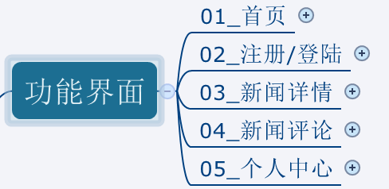(详情见思维导图)

## 技术选型

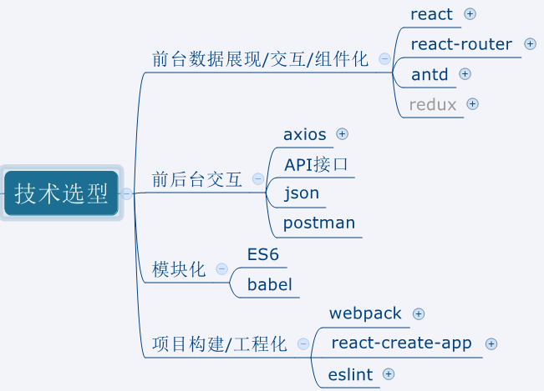

## 前端路由

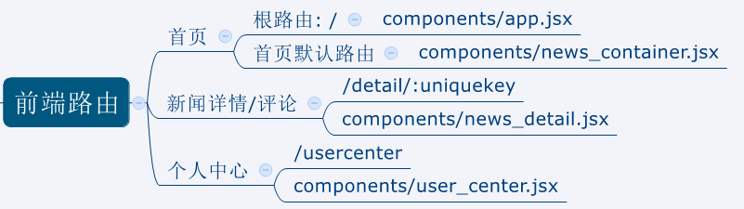

## API接口

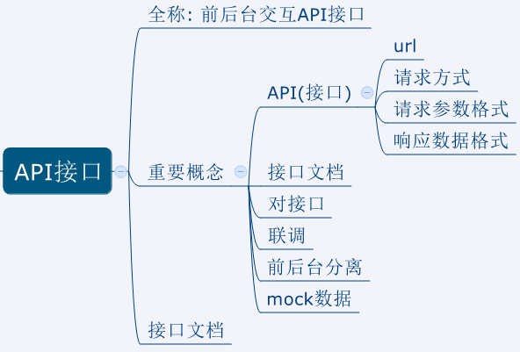

## React组件

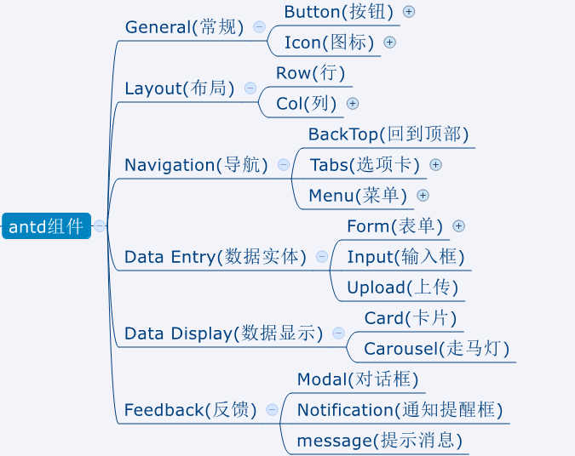

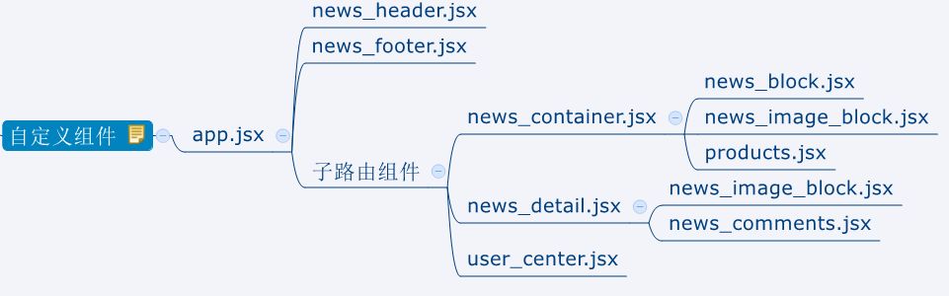

|  |
| --- |
| **\*** app.jsx: 应用根路由组件  **\*** news_header.jsx: 头部组件  **\*** news_footer.jsx: 底部组件  **\*** news_container.jsx: 首页显示各种新闻列表组件  **\*** news_block.jsx: 新闻列表组件  **\*** news_image_block.jsx: 图片新闻列表组件  **\*** products.jsx: 产品列表组件  **\*** news_detail.jsx: 新闻详情组件  **\*** news_comments.jsx: 新闻评论组件  **\*** user_center.jsx: 个人中心组件 |

## npm常用命令

|  |
| --- |
| **\*** npm init //初始化当前应用包, 生成package.json **\*** npm install //根据package.json下载所有依赖包 **\*** npm install packageName --save //下载某个运行时依赖包 **\*** npm install packageName --save-dev //下载某个开发编译期依赖包 **\*** npm install packageName -g //全局下载某个依赖包 **\*** npm install package@version //下载指定版本的某个依赖包 **\*** npm info packageName //查看某个包有远程仓库中的相关信息 **\*** npm rm packageName --save //移除已下载的运行依赖包  **\*** npm rm packageName –save-dev //移除已下载的开发依赖包 **\*** npm list //查看安装的所有的包 **\*** npm help //查看命令的详细帮助 **\*** npm install -g cnpm --registry=https://registry.npm.taobao.org //安装淘宝镜像 **\*** npm config set registry="https://registry.npm.taobao.org" //将淘宝镜像设置为npm的默认仓库  **\*** npm run xxx //执行package.json的scripts中配置的命令 |

## git常用命令

|  |
| --- |
| **\* git config --global user.name "username" //配置用户名** **\* git config --global user.password "xx@gmail.com" //配置邮箱**  **\*** git init //初始化生成一个本地仓库  **\*** git clone url //将远程仓库克隆下载到本地  **\*** git add * //添加到暂存区  **\*** git commit –m “message” //提交到本地仓库  **\*** git remote add origin url //关联到远程仓库  **\*** git push origin master //push到远程  **\*** git pull origin master //从远程pull更新 |

# 应用开发详解

## 开启项目开发

### 使用react-create-app(脚手架)搭建项目

* react-create-app是react官方提供的用于搭建基于react+webpack+es6项目的脚手架工具
* 操作:

*npm install -g create-react-app*

*create-react-app react-news*

*cd react-news*

*npm start*

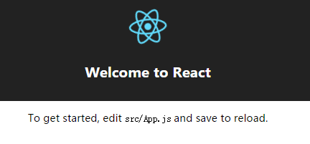

### 集成相关库

* 集成react-router

*npm install react-router@3.0.2 --save*

* 集成axios

*npm install axios --save*

* 集成antd

*npm install antd@2.7.4 --save*

*npm run eject*

*npm install babel-plugin-import --save-dev*

*修改config/* *webpack.config.dev.js*

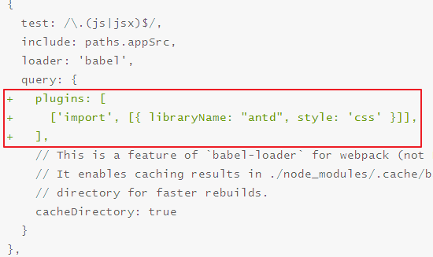

|  |
| --- |
| plugins: [  [**'import'**, [{ **libraryName**: **"antd"**, **style**: **'css'** }]] ] |

### 项目结构分析

ReactNews

|--build ---------项目打包文件夹

|--config---------webpack相关的配置文件夹(基本不需要修改)

*|--* *webpack.config.dev.js ----开发测试webpack配置*

*|--* *webpack.config.prod.js ---打包的webpack配置*

|--node_modules---第三方依赖模块文件夹

|--public

*|--* *index.html-----------------主页面*

|--scripts

*|--* *build.js-------------------build打包引用配置*

*|--* *start.js-------------------start运行引用配置*

|--src------------源码文件夹

*|--components-----------------react组件*

*|--index.js-------------------应用入口js*

|--.gitignore------git版本管制忽略的配置

|--package.json----应用包配置文件

|--README.md-------应用描述说明的readme文件

## 功能需求分析

* 演示项目功能, 对功能模块进行分析说明

## 使用react-router实现SPA

### index.js

|  |
| --- |
| **import** React **from 'react' import** ReactDOM **from 'react-dom' import** {Router, hashHistory, IndexRoute, Route} **from 'react-router' import** App **from './components/app' import** NewsContainer **from './components/news_container' import** NewsDetail **from './components/news_detail' import** UserCenter **from './components/user_center'** ReactDOM.render(  (  <**Router history=**{hashHistory}>  <**Route path='/' component=**{App}>  <**IndexRoute component=**{NewsContainer}/>  <**Route path='/detail/:uniquekey' component=**{NewsDetail}></**Route**>  <**Route path='/usercenter' component=**{UserCenter}></**Route**>  </**Route**>  </**Router**>  ),  **document**.getElementById(**'root'**) ) |

### app.jsx

|  |
| --- |
| **import** React, { Component } **from 'react'**  **export default class** App **extends** Component {  render() {  **return** (  <**div**>  <**div**>头部部分</**div**>  {**this**.**props**.**children**}  <**div**>底部部分</**div**>  </**div**>  )  } } |

### news_container.jsx

|  |
| --- |
| **import** React, {Component} **from 'react' import** {Link} **from 'react-router'  class** NewsContainer **extends** Component {  render() {  **return** (  <**div**>  <**ul**>  <**li**><**Link to="/detail/:11"**>查看新闻1</**Link**></**li**>  <**li**><**Link to="/detail/:12"**>查看新闻2</**Link**></**li**>  <**br**/>  <**li**><**Link to="/usercenter"**>个人中心</**Link**></**li**>  </**ul**>  </**div**>  )  } }  **export default** NewsContainer |

### news_detail.jsx

|  |
| --- |
| **import** React, {Component} **from 'react'  class** NewsDetail **extends** Component {  render() {  **return** (  <**div**>  新闻详情.....{**this**.**props**.**params**.**uniquekey**}  </**div**>  )  } }  **export default** NewsDetail |

### user_center.jsx

|  |
| --- |
| **import** React, {Component} **from 'react'  class** UserCenter **extends** Component {  render() {  **return** (  <**div**>  用户中心....  </**div**>  )  } }  **export default** UserCenter |

### 效果

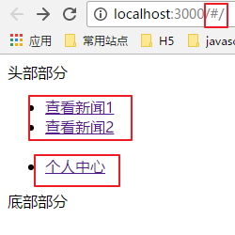 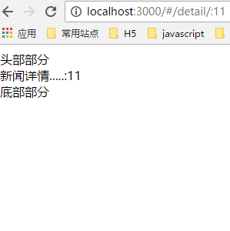 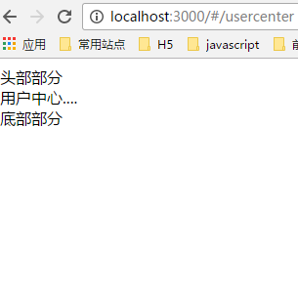

## 样式资源: pc.css

|  |
| --- |
| */*header组件*/ /*应用图标和名称*/* .**logo** {  **align-items**: **center**;  **display**: **flex**; } .**logo img** {  **width**: 48**px**;  **height**: 48**px**; } .**logo span** {  **font-size**: 24**px**;  **padding-left**: 5**px**; }  */*注册/登陆 menuItem*/* .**register** {  **float**: **right !important**; */*优先级最高*/* }  */*news_container/news_detail组件*/* .**container** {  **text-align**: **center**;  **padding-top**: 10**px**;  **margin-top**: 5**px**; } .**leftContainer** {  **width**: 400**px**;  **float**: **left**; } */*水平导航*/* .**ant-menu-horizontal**>.**ant-menu-item**>**a**, .**ant-menu-horizontal**>.**ant-menu-submenu**>**a** {  **display**: **inline-block !important**; } */*新闻列表*/* .**tabs_news** {  **padding-left**: 10**px**;  **width**: 400**px**;  **float**: **left**; } .**tabs_news li** {  **height**: 27**px**;  **line-height**: 27**px**;  **font-size**: 14**px**;  **white-space**: **nowrap**;  **overflow**: **hidden**;  **width**: 417**px**;  **float**: **left**;  **text-overflow**: **ellipsis**; } */*产品列表*/* .**tabs_product** {  **width**: 300**px**;  **padding-left**: 10**px**;  **float**: **left**; } .**tabs_product li** {  **height**: 27**px**;  **line-height**: 27**px**;  **font-size**: 14**px**;  **white-space**: **nowrap**;  **overflow**: **hidden**;  **width**: 257**px**;  **text-overflow**: **ellipsis**; } */*轮播图*/* .**carousel** {  **width**: 400**px**;  **float**: **left**; } .**carousel img** {  **width**: 400**px**;  **height**: 260**px**; }  */*image_block/news_block组件*/* .**imageblock** {  **float**: **left**; } .**custom-card** {  **padding**: 5**px**; } .**custom-card p** {  **color**: **#999**; } .**topNewsList** {  **float**: **left**;  **text-align**: **left**;  **font-size**: 12**px**;  **margin-bottom**: 10**px**; } .**topNewsList a** {  **line-height**: 22**px !important**;  **color**: **#666 !important**; }  .**ant-card**{  **margin-top**: 5**px !important**; } .**ant-card-head-title**{  **text-align**: **left !important**; } .**ant-card-body**{  **text-align**: **left !important**;  **padding**: 15**px !important**; } .**ant-tabs-bar** {  **margin-bottom**: 0 **!important**; }  */*news_detail组件*/* .**title**,.**article-title** .**title** {  **font-size**: 25**px !important**;  **line-height**: 1.4**em** } .**article-src-time** {  **font-size**: 18**px !important**; } .**article-content** .**txt** {  **font-size**: 20**px !important**; } .**article** {  **text-align**: **justify** } .**article-content** .**img** .**img-wrap**,.**hot-news img** {  **background-repeat**: **no-repeat**;  **background-position**: **center** } .**hn-title h2**,.**in-title h2** {  **z-index**: 1;  **font-weight**: 600 } **#title** {  **margin**: 16**px** 16**px** 0**!important**;  **border-bottom**: 1**px solid #e5e5e5** } .**article-title** {  **margin-bottom**: .2**rem** } **#title** .**title**,.**article-title** .**title** {  **font-size**: 1.44**rem**;  **line-height**: 1.4**em** } .**title** {  **color**: **#000** } .**article-src-time** {  **font-size**: 1**rem**;  **color**: **#999**;  **padding-bottom**: .2**rem** } .**article-content** .**section** {  **line-height**: 1.6**em**;  **margin-bottom**: .3**rem**;  **margin-top**: 0 } .**article-content** .**txt** {  **font-size**: 1.36**rem** } .**article-content** .**img** {  **margin-bottom**: .3**rem** } .**article-content** .**img** .**img-wrap** {  **position**: **relative**;  **display**: **block**;  **width**: 100%;  **height**: 0;  **overflow**: **hidden**;  **background-size**: 40% } **#content** {  **margin**: .3**rem** 16**px** 16**px** } .**article-content** .**img** .**img-wrap img** {  **position**: **absolute**;  **left**: 0;  **top**: 0;  **display**: **block**;  **width**: 60% } .**article-content** .**img** .**txt-wrap** {  **font-size**: .36**rem**;  **line-height**: 2**em** }  */*news_products组件*/* .**pro_bg**{  **background**: **#eeeeee**;  **margin-top**: 10**px**; } .**pro**{  **padding**:5**px**;  **overflow**: **hidden**; } .**pro a**{  **float**: **left**;  **line-height**: 30**px**;  **margin-right**:5**px**; } |

## 图片资源

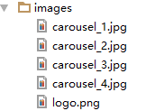

## news_header组件(头部组件)

### 1). JS

|  |
| --- |
| **import** React, {Component} **from 'react' import** {Link} **from 'react-router' import** axios **from 'axios' import** logo **from '../images/logo.png' import** {  Row, *// 行* Col, *// 列* Button,  Icon,  Menu,  Modal,  Tabs,  Form,  Input,  message } **from 'antd'  import '../componentsCss/header.css'  const** MenuItem = Menu.Item **const** TabPane = Tabs.TabPane **const** FormItem = Form.Item  **class** NewsHeader **extends** Component {   constructor(props) {  **super**(props)  **this**.**state** = {  **currentKey**: **'top'**, *// 当前MenuItem的key* **username**: **null**, *// 用户名*  **modalShow**: **false** *//注册|登陆界面是否显示* }  }   componentDidMount () {  *// 读取本地保存的数据, 如果有更新状态* **const** username = **localStorage**.getItem(**'username'**)  **if**(username) {  **this**.setState({username})  }  }   *clickMenu* = (event) => {   *// 如果点击的是注册菜单项* **if** (event.key === **'register'**) {  *// 显示modal框* **this**.setState({  **modalShow**: **true** })  }  *// 更新当前菜单项key* **this**.setState({  **currentKey**: event.key  })  }   setModalVisible(isShow) {  **this**.setState({  **modalShow**: isShow  })  }   handleSubmit (isRegist, event) {  *// 阻止默认行为* event.preventDefault()   **const** action = isRegist ? **'register'** : **'login'** *// 得到所有表单数据的集合对象* **const** formData = **this**.**props**.**form**.getFieldsValue()  **console**.log(formData)  **let** url = **`http://newsapi.gugujiankong.com/Handler.ashx?action=**${action}**`  if**(isRegist) {  **const** {r_userName, r_password, r_confirmPassword} = formData  url += **`&r_userName=**${r_userName}**&r_password=**${r_password}**&r_confirmPassword=**${r_confirmPassword}**`** } **else** {  **const** {username, password} = formData  url += **`&username=**${username}**&password=**${password}**`** }  **console**.log(url)  *// ajax请求注册/登陆* axios.get(url)  .then(response => {  **const** result = response.**data  console**.log(result, **typeof** result)  **if**(isRegist) {  **if**(result===**true**) {  message.success(**'注册成功'**)  } **else** {  message.error(**'注册失败, 重新注册'**)  }  } **else** {  **if**(result) {  message.success(**'登陆成功'**)  **const** userId = result.UserId  **const** username = result.NickUserName  *// 更新状态* **this**.setState({username})  *// 保存* **localStorage**.setItem(**'userId'**, userId)  **localStorage**.setItem(**'username'**, username)  } **else** {  message.error(**'登陆失败, 重新登陆'**)  }  }  })   *// 关闭* **this**.setState({**modalShow**: **false**})  }   *handleLogout* = () => {  *// 删除本地保存的用户信息* **localStorage**.removeItem(**'username'**)  **localStorage**.removeItem(**'userId'**)  *// 更新状态* **this**.setState({  **username**: **null**,  **userId**: **null** })  }   render() {  **const** {modalShow, username, currentKey} = **this**.**state   const** userShow = username ?  (  <**MenuItem key="logout" className="register"**>  <**Button type="primary"**>{username}</**Button**>**&nbsp;&nbsp;** <**Link to="/usercenter"**>  <**Button type="dashed"**>个人中心</**Button**>  </**Link**>**&nbsp;&nbsp;** <**Button onClick=**{**this**.*handleLogout*}>退出</**Button**>  </**MenuItem**>  )  :  (  <**MenuItem key="register" className="register"**>  <**Icon type="appstore"**/> 登陆/注册  </**MenuItem**>  )   **const** {getFieldDecorator} = **this**.**props**.**form   return** (  <**header**>  <**Row**>  <**Col span=**{1}></**Col**>  <**Col span=**{3}>  <**a href="#/" className="logo"**>  <**img src=**{logo} **alt="logo"**/>  <**span**>ReactNews</**span**>  </**a**>  </**Col**>  <**Col span=**{19}>  <**Menu mode="horizontal" selectedKeys=**{[currentKey]} **onClick=**{**this**.*clickMenu*}>  <**MenuItem key="top"**>  <**Icon type="appstore"**/>头条  </**MenuItem**>  <**MenuItem key="shehui"**>  <**Icon type="appstore"**/>社会  </**MenuItem**>  <**MenuItem key="guonei"**>  <**Icon type="appstore"**/>国内  </**MenuItem**>  <**MenuItem key="guoji"**>  <**Icon type="appstore"**/>国际  </**MenuItem**>  <**MenuItem key="yule"**>  <**Icon type="appstore"**/>娱乐  </**MenuItem**>  <**MenuItem key="tiyu"**>  <**Icon type="appstore"**/>体育  </**MenuItem**>  <**MenuItem key="keji"**>  <**Icon type="appstore"**/>科技  </**MenuItem**>  <**MenuItem key="shishang"**>  <**Icon type="appstore"**/>时尚  </**MenuItem**>   {userShow}  </**Menu**>   <**Modal  title="用户中心"  visible=**{modalShow}  **onOk=**{**this**.setModalVisible.bind(**this**, **false**)}  **onCancel=**{**this**.setModalVisible.bind(**this**, **false**)}  **okText="关闭"**>  <**Tabs type="card" onChange=**{() => **this**.**props**.**form**.resetFields()}>  <**TabPane tab="登陆" key="1"**>  <**Form onSubmit=**{**this**.handleSubmit.bind(**this**, **false**)}>  <**FormItem label="用户名"**>  {  getFieldDecorator(**'username'**)(<**Input type="text" placeholder="请输入账号"**/>)  }  </**FormItem**>  <**FormItem label="密码"**>  {  getFieldDecorator(**'password'**)(<**Input type="password" placeholder="请输入密码"**/>)  }  </**FormItem**>  <**Button type="primary" htmlType="submit"**>  登陆  </**Button**>  </**Form**>  </**TabPane**>  <**TabPane tab="注册" key="2"**>  <**Form onSubmit=**{**this**.handleSubmit.bind(**this**, **true**)}>  <**FormItem label="账户"**>  {  getFieldDecorator(**'r_userName'**)(  <**Input type="text" placeholder="请输入账号"** />  )  }  </**FormItem**>  <**FormItem label="密码"**>  {  getFieldDecorator(**'r_password'**)(  <**Input type="password" placeholder="请输入密码"** />  )  }  </**FormItem**>  <**FormItem label="确认密码"**>  {  getFieldDecorator(**'r_confirmPassword'**)(  <**Input type="password" placeholder="请再次输入您的密码"** />  )  }  </**FormItem**>  <**Button type="primary" htmlType='submit'**>注册</**Button**>  </**Form**>  </**TabPane**>  </**Tabs**>  </**Modal**>  </**Col**>  <**Col span=**{1}></**Col**>  </**Row**>  </**header**>  )  } }  **export default** Form.create()(NewsHeader) |

### 2). CSS

|  |
| --- |
| */*应用图标和名称*/* .**logo** {  **align-items**: **center**;  **display**: **flex**; } .**logo img** {  **width**: 48**px**;  **height**: 48**px**; } .**logo span** {  **font-size**: 24**px**;  **padding-left**: 5**px**; }  */*水平导航*/* .**ant-menu-horizontal**>.**ant-menu-item**>**a**, .**ant-menu-horizontal**>.**ant-menu-submenu**>**a** {  **display**: **inline-block**; }  */*注册/登陆 menuItem*/* .**register** {  **float**: **right !important**;} |

## news_footer(footer组件)

|  |
| --- |
| **import** React **from 'react' import** {Row, Col} **from 'antd'** */**  * 底部组件  */* **export default function** NewsFooter () {   **return** (  <**footer**>  <**Row**>  <**Col span=**{1}></**Col**>  <**Col span=**{22} **style=**{{**textAlign**:**'center'**, **padding**: **'20px'**}}>  2017 ReactNews. All Rights Reserved.  </**Col**>  <**Col span=**{1}></**Col**>  </**Row**>  </**footer**>  ) } |

## news_block(文本新闻列表组件)

### 1). JS

|  |
| --- |
| **import** React, {Component} **from 'react' import** {  Card } **from 'antd' import** {Link} **from 'react-router' import** axios **from 'axios'  export default class** NewsBlock **extends** Component {   **static** *propTypes* = {  **type**: React.PropTypes.string.isRequired, *// 类型* **count**: React.PropTypes.number.isRequired, *// 数量* }   constructor (props) {  **super**(props)  **this**.**state** = {  **newsArr**: []  }  }   componentDidMount () {  **const** {type, count} = **this**.**props  const** url = **`http://newsapi.gugujiankong.com/Handler.ashx?action=getnews&type=**${type}**&count=**${count}**`** axios.get(url)  .then(response => {  **const** newsArr = response.**data  this**.setState({newsArr})  })  }   render () {  **const** {newsArr} = **this**.**state  const** newsList = newsArr.**length** ? newsArr.map((news, index) => (  <**li key=**{index}>  <**Link to=**{**`detail/**${news.**uniquekey**}**`**}>  {news.**title**}  </**Link**>  </**li**>  ))  : **'没有任何新闻'  return** (  <**Card className="topNewsList"**>  <**ul**>{newsList}</**ul**>  </**Card**>  )  } } |

### 2). CSS

|  |
| --- |
| .**topNewsList** {  **float**: **left**;  **text-align**: **left**;  **font-size**: 12**px**;  **margin-bottom**: 10**px**; } .**topNewsList a** {  **line-height**: 22**px !important**;  **color**: **#666 !important**; }  .**ant-card**{  **margin-top**: 5**px !important**; } .**ant-card-head-title**{  **text-align**: **left !important**; } .**ant-card-body**{  **text-align**: **left !important**;  **padding**: 15**px !important**; } .**ant-tabs-bar** {  **margin-bottom**: 0 **!important**; } |

## news_image_block(图片新闻列表组件)

### 1). JS

|  |
| --- |
| **import** React **from 'react' import** {  **Card** } **from 'antd' import** {Link} **from 'react-router' import** axios **from 'axios'** */**  * Created by xfzhang on 2017/3/5.  * 新闻列表组件(带图片)  */* **export default class** NewsImageBlock **extends** React.**Component**{   constructor (props) {  **super**(props)  **this**.**state** = {  **newsArr**: []  }  }   componentDidMount () {  **const** {type, count} = **this**.**props  const** url = **`http://newsapi.gugujiankong.com/Handler.ashx?action=getnews&type=**${type}**&count=**${count}**`** axios.get(url)  .then(response => {  **const** newsArr = response.**data  this**.*setState*({newsArr})  })  }   render () {  **const** imageStyle = {  **width**: **this**.**props**.**imageWidth**,  **height**: **"90px"**,  **display**: **'block'** }  **const** titleStyle = {  **width**: **this**.**props**.**imageWidth**,  **whiteSpace**: **"nowrap"**, **// 不进行换行**  **overflow**: **"hidden"**, **// 超出部分自动隐藏**  **textOverflow**: **"ellipsis" // 显示省略号** };  **const** {newsArr} = **this**.**state  const** newsList = newsArr.**length** ? newsArr.map((news, index) => (  <**div key=**{index} **className="imageblock"**>  <**Link to=**{**`detail/**${news.**uniquekey**}**`**}>  <**div**>  <**img src=**{news.thumbnail_pic_s} **alt="" style=**{imageStyle}/>  </**div**>  <**div className="custom-card"**>  <**h3 style=**{titleStyle}>{news.**title**}</**h3**>  <**p**>{news.author_name}</**p**>  </**div**>  </**Link**>  </**div**>  ))  : **'没有加载到任何新闻'   const** {cardTitle, cardWidth} = **this**.**props  return** (  <**Card title=**{cardTitle} **style=**{{**width**:cardWidth}} **className="topNewsList"**>  {newsList}  </**Card**>  )  } }  NewsImageBlock.**propTypes** = {  **cardTitle**: React.**PropTypes**.**string**.isRequired,  **cardWidth**: React.**PropTypes**.**string**.isRequired,  **type**: React.**PropTypes**.**string**.isRequired,  **count**: React.**PropTypes**.**number**.isRequired,  **imageWidth**: React.**PropTypes**.**string**.isRequired, } |

### 2). CSS

|  |
| --- |
| .**imageblock** {  **float**: **left**; } .**custom-card** {  **padding**: 5**px**; } .**custom-card p** {  **color**: **#999**; } |

## news_products(新闻产品列表组件)

### 1). JS

|  |
| --- |
| **import** React **from 'react'**; **import** {Link} **from 'react-router'**;  **export default class** NewsProducts **extends** React.Component{  render(){  **return** (  <**div**>  <**div className="pro pro_bg"**>  <**Link to="http://yuehui.163.com/?from=wscp"**>同城约会</**Link**>  <**Link to="http://sports.qq.com/"**>腾讯体育</**Link**>  <**Link to="https://www.zhibo8.cc/"**>直播吧</**Link**>  <**Link to="https://www.zhibo8.cc/zuqiu/"**>足球直播</**Link**>  <**Link to="http://yuehui.163.com/?from=wscp"**>同城约会</**Link**>  <**Link to="http://sports.qq.com/"**>腾讯体育</**Link**>  <**Link to="https://www.zhibo8.cc/"**>直播吧</**Link**>  <**Link to="https://www.zhibo8.cc/zuqiu/"**>足球直播</**Link**><**Link to="http://yuehui.163.com/?from=wscp"**>同城约会</**Link**>  <**Link to="http://sports.qq.com/"**>腾讯体育</**Link**>  <**Link to="https://www.zhibo8.cc/"**>直播吧</**Link**>  <**Link to="https://www.zhibo8.cc/zuqiu/"**>足球直播</**Link**><**Link to="http://yuehui.163.com/?from=wscp"**>同城约会</**Link**>  <**Link to="http://sports.qq.com/"**>腾讯体育</**Link**>  <**Link to="https://www.zhibo8.cc/"**>直播吧</**Link**>  <**Link to="https://www.zhibo8.cc/zuqiu/"**>足球直播</**Link**>  </**div**>  <**div className="pro"**>  <**Link to="http://yuehui.163.com/?from=wscp"**>同城约会</**Link**>  <**Link to="http://sports.qq.com/"**>腾讯体育</**Link**>  <**Link to="https://www.zhibo8.cc/"**>直播吧</**Link**>  <**Link to="https://www.zhibo8.cc/zuqiu/"**>足球直播</**Link**>  <**Link to="http://yuehui.163.com/?from=wscp"**>同城约会</**Link**>  <**Link to="http://sports.qq.com/"**>腾讯体育</**Link**>  <**Link to="https://www.zhibo8.cc/"**>直播吧</**Link**>  <**Link to="https://www.zhibo8.cc/zuqiu/"**>足球直播</**Link**><**Link to="http://yuehui.163.com/?from=wscp"**>同城约会</**Link**>  <**Link to="http://sports.qq.com/"**>腾讯体育</**Link**>  <**Link to="https://www.zhibo8.cc/"**>直播吧</**Link**>  <**Link to="https://www.zhibo8.cc/zuqiu/"**>足球直播</**Link**><**Link to="http://yuehui.163.com/?from=wscp"**>同城约会</**Link**>  <**Link to="http://sports.qq.com/"**>腾讯体育</**Link**>  <**Link to="https://www.zhibo8.cc/"**>直播吧</**Link**>  <**Link to="https://www.zhibo8.cc/zuqiu/"**>足球直播</**Link**>  </**div**>  <**div className="pro pro_bg"**>  <**Link to="http://yuehui.163.com/?from=wscp"**>同城约会</**Link**>  <**Link to="http://sports.qq.com/"**>腾讯体育</**Link**>  <**Link to="https://www.zhibo8.cc/"**>直播吧</**Link**>  <**Link to="https://www.zhibo8.cc/zuqiu/"**>足球直播</**Link**>  <**Link to="http://yuehui.163.com/?from=wscp"**>同城约会</**Link**>  <**Link to="http://sports.qq.com/"**>腾讯体育</**Link**>  <**Link to="https://www.zhibo8.cc/"**>直播吧</**Link**>  <**Link to="https://www.zhibo8.cc/zuqiu/"**>足球直播</**Link**><**Link to="http://yuehui.163.com/?from=wscp"**>同城约会</**Link**>  <**Link to="http://sports.qq.com/"**>腾讯体育</**Link**>  <**Link to="https://www.zhibo8.cc/"**>直播吧</**Link**>  <**Link to="https://www.zhibo8.cc/zuqiu/"**>足球直播</**Link**><**Link to="http://yuehui.163.com/?from=wscp"**>同城约会</**Link**>  <**Link to="http://sports.qq.com/"**>腾讯体育</**Link**>  <**Link to="https://www.zhibo8.cc/"**>直播吧</**Link**>  <**Link to="https://www.zhibo8.cc/zuqiu/"**>足球直播</**Link**>  </**div**>  </**div**>  )  } } |

### 2). CSS

|  |
| --- |
| .**pro_bg**{  **background**: **#eeeeee**;  **margin-top**: 10**px**; } .**pro**{  **padding**:5**px**;  **overflow**: **hidden**; } .**pro a**{  **float**: **left**;  **line-height**: 30**px**;  **margin-right**:5**px**; } |

## news_container(所有新闻容器组件)

### 1). JS

|  |
| --- |
| **import** React **from 'react' import** {  **Row**,  **Col**,  **Carousel**,  **Tabs** } **from 'antd' const** TabPane = **Tabs**.*TabPane* **import** NewsImageBlock **from './news_image_block' import** NewsBlock **from './news_block' import** *NewsProducts* **from './news_products'  import** carousel_1 **from '../images/carousel_1.jpg' import** carousel_2 **from '../images/carousel_2.jpg' import** carousel_3 **from '../images/carousel_3.jpg' import** carousel_4 **from '../images/carousel_4.jpg'** */**  * Created by xfzhang on 2017/3/3.  * 首页主体组件  */* **export default class** NewsContainer **extends** React.**Component** {   render () {  **return** (  <**div**>  <**Row className='container'**>  <**Col span=**{1}/>  <**Col span=**{22}>   <**div className="leftContainer" style=**{{**width**: **"35%"**}}>  <**Carousel autoplay infinite dots**>  <**div**><**img src=**{carousel_1}/></**div**>  <**div**><**img src=**{carousel_2}/></**div**>  <**div**><**img src=**{carousel_3}/></**div**>  <**div**><**img src=**{carousel_4}/></**div**>  </**Carousel**>  <**NewsImageBlock type='guoji' cardTitle='国际新闻'  count=**{6} **cardWidth='400px' imageWidth='112px'**/>  </**div**>   <**Tabs className='tabs_news' style=**{{**width**: **"35%"**}}>  <**TabPane tab="头条新闻" key="1"**>  <**NewsBlock type="top" count=**{22}/>  </**TabPane**>  <**TabPane tab="国际新闻" key="2"**>  <**NewsBlock type="guoji" count=**{22}/>  </**TabPane**>  </**Tabs**>   <**Tabs className="tabs_product" style=**{{**width**: **"30%"**}}>  <**TabPane tab="React News产品" key="1"**>  <**NewsProducts** />  </**TabPane**>  </**Tabs**>   <**div**>  <**NewsImageBlock count=**{8} **type="guonei" cardWidth="100%" cardTitle="国内新闻" imageWidth="132px"**/>  <**NewsImageBlock count=**{16} **type="yule" cardWidth="100%" cardTitle="娱乐新闻" imageWidth="132px"**/>  </**div**>  </**Col**>  <**Col span=**{1}/>  </**Row**>  </**div**>  )  } } |

### 2). CSS

|  |
| --- |
| .**container** {  **text-align**: **center**;  **padding-top**: 10**px**;  **margin-top**: 5**px**; } .**leftContainer** {  **width**: 400**px**;  **float**: **left**; } */*新闻列表*/* .**tabs_news** {  **padding-left**: 10**px**;  **width**: 400**px**;  **float**: **left**; } .**tabs_news li** {  **height**: 27**px**;  **line-height**: 27**px**;  **font-size**: 14**px**;  **white-space**: **nowrap**;  **overflow**: **hidden**;  **width**: 417**px**;  **float**: **left**;  **text-overflow**: **ellipsis**; } */*产品列表*/* .**tabs_product** {  **width**: 300**px**;  **padding-left**: 10**px**;  **float**: **left**; } .**tabs_product li** {  **height**: 27**px**;  **line-height**: 27**px**;  **font-size**: 14**px**;  **white-space**: **nowrap**;  **overflow**: **hidden**;  **width**: 257**px**;  **text-overflow**: **ellipsis**; } */*轮播图*/* .ant-**carousel** {  **width**: 400**px**;  **float**: **left**; } .ant-**carousel img** {  **width**: 400**px**;  **height**: 260**px**; } |

## news_comments(新闻评论组件)

|  |
| --- |
| **import** React, {PropTypes} **from 'react' import** {  Form,  Input,  Button,  Card,  notification } **from 'antd' import** axios **from 'axios'  const** FormItem = Form.Item  */**  * 评论组件  */* **class** NewsComments **extends** React.Component {   **static** *propTypes* = {  **uniquekey**: PropTypes.string.isRequired  }   constructor(props) {  **super**(props)  **this**.**state** = {  **comments**: []  }  }   componentDidMount() {  **const** {uniquekey} = **this**.**props  const** url = **`http://newsapi.gugujiankong.com/Handler.ashx?action=getcomments&uniquekey=**${uniquekey}**`** axios.get(url)  .then(response => {  **const** comments = response.**data  this**.setState({comments})  })  }   handleSubmit(event) {  event.preventDefault()   **let** userId = **localStorage**.getItem(**'userId'**)  **if**(!userId) {  alert(**'请先登陆'**)  **return** } **const** {comment} = **this**.**props**.**form**.getFieldsValue()  **const** {uniquekey} = **this**.**props  const** url = **`http://newsapi.gugujiankong.com/Handler.ashx?action=comment&userid=** ${userId}**&uniquekey=**${uniquekey}**&commnet=**${comment}**`** axios.get(url)  .then(response => {  **this**.componentDidMount()  **this**.**props**.**form**.resetFields()  notification.success({**message**: **'提交成功!'**})  })  }   addUserCollection() {   **let** userId = **localStorage**.getItem(**'userId'**)  **if**(!userId) {  alert(**'请先登陆'**)  **return** } **const** url = **"http://newsapi.gugujiankong.com/Handler.ashx?action=uc&userid="** + userId + **"&uniquekey="** + **this**.**props**.**uniquekey** axios.get(url)  .then(response => {  *//收藏成功以后进行一下全局的提醒* notification.success({**message**: **'ReactNews提醒'**, **description**: **'收藏此文章成功'**})  })  }   render() {  **const** {getFieldDecorator} = **this**.**props**.**form  const** {comments} = **this**.**state  const** commentList = comments.**length** ? comments.map((comment, index) => (  <**Card key=**{index} **title=**{comment.UserName} **extra=**{**`发布于**${comment.datetime}**`**}>  <**p**>{comment.Comments}</**p**>  </**Card**>  ))  : **'没有加载到任何评论'   return** (  <**div style=**{{**padding**: **'10px'**}}>  {commentList}  <**Form onSubmit=**{**this**.handleSubmit.bind(**this**)}>  <**FormItem label="您的评论"**>  {  getFieldDecorator(**'comment'**)(<**Input type="textarea" placeholder="随便写点什么"**/>)  }  </**FormItem**>  <**Button type='primary' htmlType="submit"**>提交评论</**Button**>  **&nbsp;&nbsp;** <**Button type='primary' htmlType="button" onClick=**{**this**.addUserCollection.bind(**this**)}>收藏该文章</**Button**>  </**Form**>  </**div**>  )  } } **export default** Form.create()(NewsComments) |

## news_detail(新闻详情组件)

### 1). JS

|  |
| --- |
| **import** React, {Component} **from 'react' import** {  Row,  Col,  BackTop } **from 'antd' import** axios **from 'axios'  import** NewsImageBlock **from './news_image_block' import** NewsComments **from './news_comments'** */**  * 新闻详情组件  */* **export default class** NewsDetail **extends** Component {   constructor(props) {  **super**(props)  *// 初始化数据* **this**.**state** = {  **news**: {}  }  }   componentWillReceiveProps(newProps) {  **console**.log(**'componentWillReceiveProps() '**, newProps)  **this**.*getNews*(newProps)  }   componentDidMount() {  **this**.*getNews*(**this**.**props**)  }   *getNews* = (props) => {  **const** {uniquekey} = props.params  **const** url = **`http://newsapi.gugujiankong.com/Handler.ashx?action=getnewsitem&uniquekey=**${uniquekey}**`** axios.get(url)  .then(response => {  **const** news = response.**data  this**.setState({news})  **document**.**title** = news.**title** + **" - React News | React 驱动的新闻平台"**;  })  }   render() {  **const** {pagecontent} = **this**.**state**.**news   return** (  <**div**>  <**Row**>  <**Col span=**{1}></**Col**>  <**Col span=**{16} **className="container"**>  <**div dangerouslySetInnerHTML=**{{**__html**: pagecontent}}/>  <**hr**/>  <**NewsComments uniquekey=**{**this**.**props**.params.**uniquekey**}/>  </**Col**>  <**Col span=**{6}>  <**NewsImageBlock count=**{40} **type="top"  cardWidth="100%" cardTitle="相关新闻" imageWidth="150px"**/>  </**Col**>  <**Col span=**{1}></**Col**>  </**Row**>  <**BackTop** />  </**div**>  )  } } |

### 2). CSS

|  |
| --- |
| .**title**,.**article-title** .**title** {  **font-size**: 25**px !important**;  **line-height**: 1.4**em** } .**article-src-time** {  **font-size**: 18**px !important**; } .**article-content** .**txt** {  **font-size**: 20**px !important**; } .**article** {  **text-align**: **justify** } .**article-content** .**img** .**img-wrap**,.**hot-news img** {  **background-repeat**: **no-repeat**;  **background-position**: **center** } .**hn-title h2**,.**in-title h2** {  **z-index**: 1;  **font-weight**: 600 } **#title** {  **margin**: 16**px** 16**px** 0**!important**;  **border-bottom**: 1**px solid #e5e5e5** } .**article-title** {  **margin-bottom**: .2**rem** } **#title** .**title**,.**article-title** .**title** {  **font-size**: 1.44**rem**;  **line-height**: 1.4**em** } .**title** {  **color**: **#000** } .**article-src-time** {  **font-size**: 1**rem**;  **color**: **#999**;  **padding-bottom**: .2**rem** } .**article-content** .**section** {  **line-height**: 1.6**em**;  **margin-bottom**: .3**rem**;  **margin-top**: 0 } .**article-content** .**txt** {  **font-size**: 1.36**rem** } .**article-content** .**img** {  **margin-bottom**: .3**rem** } .**article-content** .**img** .**img-wrap** {  **position**: **relative**;  **display**: **block**;  **width**: 100%;  **height**: 0;  **overflow**: **hidden**;  **background-size**: 40% } **#content** {  **margin**: .3**rem** 16**px** 16**px** } .**article-content** .**img** .**img-wrap img** {  **position**: **absolute**;  **left**: 0;  **top**: 0;  **display**: **block**;  **width**: 60% } .**article-content** .**img** .**txt-wrap** {  **font-size**: .36**rem**;  **line-height**: 2**em** } |

## user_center(用户中心组件)

|  |
| --- |
| **import** React, {Component} **from 'react' import** {  Row,  Col,  Modal,  Tabs,  Icon,  Card,  Upload } **from 'antd' import** axios **from 'axios' const** TabPane = Tabs.TabPane  */**  * 用户个人中心组件  */* **class** UserCenter **extends** Component {   constructor(props) {  **super**(props)  **this**.**state** = {  **userCollections**: [],  **userComments**: [],  **preViewImage**: **''**,  **previewVisible**: **false**,  **fileList**: [{  **uid**: -1,  **name**: **'xxx.png'**,  **status**: **'done'**,  **url**: **'https://zos.alipayobjects.com/rmsportal/jkjgkEfvpUPVyRjUImniVslZfWPnJuuZ.png'**,  }],  }  }   componentDidMount() {  *//获取用户收集列表数据* **const** userId = **localStorage**.getItem(**'userId'**) **let** url = **"http://newsapi.gugujiankong.com/Handler.ashx?action=getuc&userid="** + userId  axios.get(url)  .then(response=> {  **const** userCollections = response.**data  this**.setState({userCollections})  })   *//获取用户评论列表数据* url = **"http://newsapi.gugujiankong.com/Handler.ashx?action=getusercomments&userid="** + userId  axios.get(url)  .then(response => {  **const** userComments = response.**data  this**.setState({userComments})  })  }   *handleCancel* = () => **this**.setState({**previewVisible**: **false**})   *handlePreview* = (file) => {  **this**.setState({  **previewImage**: file.**url** || file.thumbUrl,  **previewVisible**: **true**,  });  }   *handleChange* = ({fileList}) => {  **console**.log(fileList)  **this**.setState({fileList})  }   render() {  **const** {userCollections, userComments} = **this**.**state   const** userCollectionsList = userCollections.**length** ? userCollections.map((uc, index) => (  <**Card key=**{index} **title=**{uc.**uniquekey**}  **extra=**{<**a href=**{**`/#/news_detail/**${uc.**uniquekey**}**`**}>查看</**a**>}>  <**p**>{uc.Title}</**p**>  </**Card**>  ))  : **'您还没有收藏任何的新闻，快去收藏一些新闻吧。'   const** userCommentsList = userComments.**length** ? userComments.map((comment, index)=>(  <**Card key=**{index} **title=**{**`于** ${comment.datetime} **评论了文章** ${comment.**uniquekey**}**`**}  **extra=**{<**a href=**{**`/#/news_detail/**${comment.**uniquekey**}**`**}>查看</**a**>}>  <**p**>{comment.Comments}</**p**>  </**Card**>  ))  : **'您还没有发表过任何评论。'   const** {previewVisible, previewImage, fileList} = **this**.**state  const** uploadButton = (  <**div**>  <**Icon type="plus"**/>  <**div className="ant-upload-text"**>上传照片</**div**>  </**div**>  );   **return** (  <**div**>  <**Row**>  <**Col span=**{1}></**Col**>  <**Col span=**{22}>  <**Tabs**>  <**TabPane tab="我的收藏列表" key="1"**>  {userCollectionsList}  </**TabPane**>  <**TabPane tab="我的评论列表" key="2"**>  {userCommentsList}  </**TabPane**>  <**TabPane tab="头像设置" key="3"**>  <**div className="clearfix"**>  <**Upload  action="http://jsonplaceholder.typicode.com/photos"  listType="picture-card"  fileList=**{fileList}  **onPreview=**{**this**.*handlePreview*}  **onChange=**{**this**.*handleChange*}>  {uploadButton}  </**Upload**>  <**Modal visible=**{previewVisible} **footer=**{**null**} **onCancel=**{**this**.*handleCancel*}>  <**img alt="预览" style=**{{**width**: **'100%'**}} **src=**{previewImage}/>  </**Modal**>  </**div**>  </**TabPane**>  </**Tabs**>  </**Col**>  <**Col span=**{1}></**Col**>  </**Row**>  </**div**>  )  } }  **export default** UserCenter |

## 实现PC/移动的响应式

### React扩展库: react-responsive

通过<https://github.com/contra/react-responsive>学习

### 使用[react-responsive](https://github.com/contra/react-responsive)

|  |
| --- |
| **import** React **from 'react' import** ReactDOM **from 'react-dom' import** {Router, hashHistory, IndexRoute, Route} **from 'react-router' import** MediaQuery **from 'react-responsive'  import** App **from './components/app' import** NewsContainer **from './components/news_container' import** NewsDetail **from './components/news_detail' import** UserCenter **from './components/user_center'  import** MobileApp **from './components/mobile_app' import** MobileNewsContainer **from './components/mobile_news_container' import** MobileNewsDetail **from './components/mobile_news_detail' import** MobileUserCenter **from './components/mobile_user_center'** ReactDOM.render(  (  <**div**>  <**MediaQuery query='(min-device-width: 1224px)'**>  <**Router history=**{hashHistory}>  <**Route path='/' component=**{App}>  <**IndexRoute component=**{NewsContainer}/>  <**Route path='/detail/:uniquekey' component=**{NewsDetail}></**Route**>  <**Route path='/usercenter' component=**{UserCenter}></**Route**>  </**Route**>  </**Router**>  </**MediaQuery**>  <**MediaQuery query='(max-device-width: 1224px)'**>  <**Router history=**{hashHistory}>  <**Route path='/' component=**{MobileApp}>  <**IndexRoute component=**{MobileNewsContainer}/>  <**Route path='/detail/:uniquekey' component=**{MobileNewsDetail}></**Route**>  <**Route path='/usercenter' component=**{MobileUserCenter}></**Route**>  </**Route**>  </**Router**>  </**MediaQuery**>  </**div**>  ),   **document**.getElementById(**'root'**) ) |

### 修改index.html的viewport

|  |
| --- |
| <**meta name="viewport"   content="width=device-width,initial-scale=1,maximum-scale=1,minimum-scale=1,user-scalable=no"**> |

## PC和移动使用2套样式

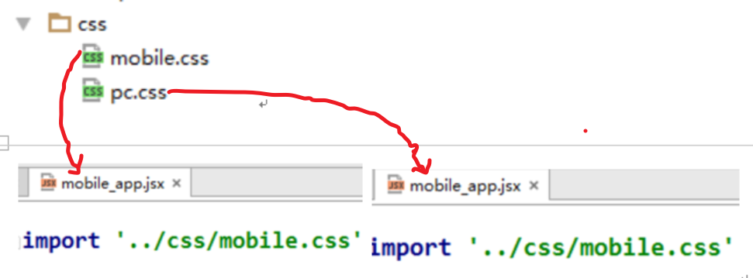

|  |
| --- |
| **html** {  **font-size**: 50**px**; }  */*header组件*/* **#mobileheader** {  **flex**: 1;  **background**: **#f6f6f6**; }  **#mobileheader header** {  **border-bottom**: 1**px solid #2db7f5**;  **padding-left**: 10**px**; }  **#mobileheader header img** {  **height**: 50**px**; }  **#mobileheader header span** {  **font-size**: 35**px**;  **vertical-align**: **top**;  **padding-left**: 5**px**;  **color**: **#2db7f5**; }  **#mobileheader i** {  **font-size**: 0.5**rem**;  **float**: **right**;  **margin-right**: 0.3**rem**;  **margin-top**: 0.3**rem**;  **color**: **#2db7f5**; }  **#mobileheader ul li** {  **font-size**: 30**px**; }  **#mobileheader** .**slick-list img** {  **height**: 220**px**;  **width**: 100%; }  */*news_block组件*/* .**m_article** {  **font-size**: 14**px**;  **padding**: .2**rem** 0;  **border-bottom**: 1**px solid #e5e5e5**;  **margin**: 0 .3**rem** }  .**m_article** .**m_article_img** {  **float**: **left**;  **width**: 27%;  **height**: 1.4**rem**;  **overflow**: **hidden**;  **position**: **relative**;  **margin-right**: .2**rem** }  .**m_article** .**m_article_img img** {  **width**: 100%;  **display**: **block**;  **min-height**: 1.4**rem** }  .**m_article** .**m_article_desc** .**m_article_channel** {  **display**: **inline-block**;  **color**: **rgba**(255, 51, 51, 0.9);  **font-size**: 12**px**;  **padding**: 2**px**;  **line-height**: 12**px**;  **margin-right**: .1**rem**;  **background**: **url**(**http://img2.cache.netease.com/f2e/wap/common/images/border_red.png**) **no-repeat**;  **background-size**: 100% 100% }  .**m_article** .**m_article_desc** .**m_article_time** {  **font-size**: .24**rem**;  **color**: **#888**;  **display**: **inline-block** }  .**m_article** .**m_article_desc** .**m_article_desc_l** {  **float**: **left** }  .**m_article** .**m_article_info** {  **overflow**: **hidden**;  **padding-bottom**: 4**px** }  .**m_article** .**m_article_info** .**m_article_title** {  **text-align**: **left**;  **font-size**: .34**rem**;  **margin-bottom**: .2**rem**;  **color**: **#404040**;  **line-height**: .42**rem**;  **width**: 100%;  **display**: **-webkit-box**;  **-webkit-line-clamp**: 2;  **overflow**: **hidden**;  **-webkit-box-orient**: **vertical** }  */*news_detail组件*/* **#mobileDetailsContainer** .**title**, .**article-title** .**title** {  **font-size**: 0.44**rem !important**;  **line-height**: 1.4**em** }  **#mobileDetailsContainer** .**article-src-time** {  **font-size**: 0.3**rem !important**; }  **#mobileDetailsContainer** .**article-content** .**txt** {  **font-size**: 0.36**rem**; }  **#mobileDetailsContainer** .**ant-row** {  **margin-top**: 20**px**; } |

## mobile_app组件

|  |
| --- |
| **import** React, {Component} **from 'react' import** MobileNewsHeader **from './mobile_news_header' import** *NewsFooter* **from './news_footer' import '../componentsCss/mobile.css'** */**  * mobile端 应用根路由组件  */* **class** MobileApp **extends** Component {  render() {  **return** (  <**div**>  <**MobileNewsHeader** />  {**this**.**props**.children}  <**NewsFooter** />  </**div**>  )  } }  **export default** MobileApp |

## mobile_news_header组件

|  |
| --- |
| **import** React, {Component} **from 'react' import** {  Icon,  Button,  Modal,  Tabs,  Form,  Input,  message } **from 'antd' import** {Link} **from 'react-router' import** axios **from 'axios'  import** logo **from '../images/logo.png'  const** TabPane = Tabs.TabPane **const** FormItem = Form.Item  */* 移动端 头部组件  */* **class** MobileNewsHeader **extends** Component {   constructor(props) {  **super**(props)  **this**.**state** = {  **username**: **null**,  **modalVisible**: **false** }  }   *componentWillMount* = () => {  *//读取保存的数据* **const** username = **localStorage**.getItem(**'username'**)  **if** (username) {  *//更新状态* **this**.setState({username})  }  }   *//更新状态modalVisible  setModalVisible* = (modalVisible) => {  **this**.setState({modalVisible})  }   *//处理提交(注册/登陆)  handleSubmit* = (isRegist, event) => {  *//阻止表单的提交默认行为* event.preventDefault()   *//收集输入数据, 准备url* **const** {username, password, r_userName, r_password, r_confirmPassword} = **this**.**props**.**form**.getFieldsValue()  **const** action = isRegist ? **'register'** : **'login'  const** url = **`http://newsapi.gugujiankong.com/Handler.ashx?action=**${action}**&username=**${username}**&password=**${password}**&r_userName=**${r_userName}**&r_password=**${r_password}**&r_confirmPassword=**${r_confirmPassword}**`** *//发送ajax请求* axios.get(url)  .then(response => {  **const** result = response.**data  if** (isRegist) {  message.success(**'注册成功'**)  } **else** {  **if** (!result) { *//登陆失败* message.error(**'登陆失败'**)  } **else** {  message.success(**'登陆成功'**)  const **userId**: result.UserId,  const **username**: result.NickUserName  *//更新状态* **this**.setState({username})  *//保存到localStorage* **localStorage**.setItem(**'userId'**, userId)  **localStorage**.setItem(**'username'**, username)  }  }  })   *//更新modalVisible* **this**.setState({**modalVisible**: **false**})  }   render() {  **const** {username, modalVisible} = **this**.**state  const** {getFieldDecorator} = **this**.**props**.**form   const** userItem = username  ? <**Link to='/usercenter'**>  <**Icon type="inbox"**/>  </**Link**>  : <**Icon type="setting" onClick=**{**this**.*setModalVisible*.bind(**this**, **true**)}/>   **return** (  <**div id="mobileheader"**>  <**header**>  <**div**>  <**Link to='/'**>  <**img src=**{logo} **alt="logo"**/>  <**span**>ReactNews2</**span**>  </**Link**>  {userItem}  </**div**>  </**header**>  <**Modal title="用户中心"  visible=**{modalVisible}  **onOk=**{**this**.*setModalVisible*.bind(**this**, **false**)}  **onCancel=**{**this**.*setModalVisible*.bind(**this**, **false**)}  **okText='关闭'**>  <**Tabs type="card" onChange=**{() => **this**.**props**.**form**.resetFields()}>  <**TabPane tab="登陆" key="1"**>  <**Form onSubmit=**{**this**.*handleSubmit*.bind(**this**, **false**)}>  <**FormItem label='账户'**>  {  getFieldDecorator(**'username'**)(  <**Input placeholder="请输入账号"**/>  )  }  </**FormItem**>  <**FormItem label='密码'**>  {  getFieldDecorator(**'password'**)(  <**Input type='password' placeholder="请输入密码"**/>  )  }  </**FormItem**>  <**Button type='primary' htmlType="submit"**>登陆</**Button**>  </**Form**>  </**TabPane**>  <**TabPane tab="注册" key="2"**>  <**Form onSubmit=**{**this**.*handleSubmit*.bind(**this**, **true**)}>  <**FormItem label='账户'**>  {  getFieldDecorator(**'r_userName'**)(  <**Input placeholder="请输入账号"**/>  )  }  </**FormItem**>  <**FormItem label='密码'**>  {  getFieldDecorator(**'r_password'**)(  <**Input type='password' placeholder="请输入密码"**/>  )  }  </**FormItem**>  <**FormItem label='确认密码'**>  {  getFieldDecorator(**'r_confirmPassword'**)(  <**Input type='password' placeholder="请输入确认密码"**/>  )  }  </**FormItem**>  <**Button type='primary' htmlType="submit"**>注册</**Button**>  </**Form**>  </**TabPane**>  </**Tabs**>  </**Modal**>  </**div**>   )  } }  **export default** Form.create()(MobileNewsHeader) |

## mobile_news_block组件

|  |
| --- |
| **import** React **from 'react' import** {**Card**} **from 'antd' import** {Link} **from 'react-router' import** axios **from 'axios'** */**  * Created by xfzhang on 2017/3/5.  * mobile端新闻列表组件  */* **export default class** MobileNewsBlock **extends** React.**Component**{  **static** *propTypes* = {  **type**: React.**PropTypes**.**string**.isRequired,  **count**: React.**PropTypes**.**number**.isRequired, }  constructor () {  **super**()  **this**.*state* = {  **newsArr**: []  }  }   componentDidMount () {  **const** {type, count} = **this**.**props  const** url = **`http://newsapi.gugujiankong.com/Handler.ashx?action=getnews&type=**${type}**&count=**${count}**`** axios.get(url)  .then(response => {  **const** newsArr = response.data  **this**.*setState*({newsArr})  })  }   render () {   **const** {newsArr} = **this**.**state  const** newsList = newsArr.**length** ? newsArr.map((newsItem, index) => (  <**Card key=**{index} **className="m_article list-item special_section clearfix"**>  <**Link to=**{**`detail/**${newsItem.**uniquekey**}**`**}>  <**div className="m_article_img"**>  <**img src=**{newsItem.thumbnail_pic_s} **alt=**{newsItem.**title**} />  </**div**>  <**div className="m_article_info"**>  <**div className="m_article_title"**>  <**span**>{newsItem.**title**}</**span**>  </**div**>  <**div className="m_article_desc clearfix"**>  <**div className="m_article_desc_l"**>  <**span className="m_article_channel"**>{newsItem.realtype}</**span**>  <**span className="m_article_time"**>{newsItem.**date**}</**span**>  </**div**>  </**div**>  </**div**>  </**Link**>  </**Card**>  ))  : **'没有加载到任何新闻'**;  **return** (  <**div**>  {newsList}  </**div**>  )  } }  MobileNewsBlock.**propTypes** = {  **type**: React.**PropTypes**.**string**.isRequired,  **count**: React.**PropTypes**.**number**.isRequired, } |

## mobile_news_container组件

|  |
| --- |
| **import** React **from 'react' import** {  Carousel,  Tabs } **from 'antd' import** MobileNewsBlock **from './mobile_news_block'  import** carousel_1 **from '../images/carousel_1.jpg' import** carousel_2 **from '../images/carousel_2.jpg' import** carousel_3 **from '../images/carousel_3.jpg' import** carousel_4 **from '../images/carousel_4.jpg'  const** TabPane = Tabs.TabPane  */**  * mobile端: 首页主体组件  */* **export default class** MobileNewsContainer **extends** React.Component {   render () {   **return** (  <**Tabs**>  <**TabPane tab="头条" key="top"**>  <**div style=**{{**width**: **'100%'**}}>  <**Carousel autoplay infinite**>  <**div**><**img src=**{carousel_1}/></**div**>  <**div**><**img src=**{carousel_2}/></**div**>  <**div**><**img src=**{carousel_3}/></**div**>  <**div**><**img src=**{carousel_4}/></**div**>  </**Carousel**>  </**div**>  <**MobileNewsBlock count=**{20} **type="top"**/>  </**TabPane**>  <**TabPane tab="社会" key="shehui"**>  <**MobileNewsBlock count=**{20} **type="shehui"**/>  </**TabPane**>  <**TabPane tab="国内" key="guonei"**>  <**MobileNewsBlock count=**{20} **type="guonei"**/>  </**TabPane**>  <**TabPane tab="国际" key="guoji"**>  <**MobileNewsBlock count=**{20} **type="guoji"**/>  </**TabPane**>  <**TabPane tab="娱乐" key="yule"**>  <**MobileNewsBlock count=**{20} **type="yule"**/>  </**TabPane**>  </**Tabs**>  )  } } |

## mobile_news_detail组件

|  |
| --- |
| **import** React **from 'react' import** {BackTop} **from 'antd'**; **import** axios **from 'axios'  import** NewsComment **from './news_comments'**;  */**  * 移动端 新闻详情组件  */* **export default class** MobileNewsDetails **extends** React.Component{   constructor (props) {  **super**(props)  **this**.**state** = {  **news**: **''** }  }   componentDidMount () {  **const** {uniquekey} = **this**.**props**.params  **const** url = **`http://newsapi.gugujiankong.com/Handler.ashx?action=getnewsitem&uniquekey=**${uniquekey}**`** axios.get(url)  .then(response => {  **const** news = response.**data  this**.setState({news})  **document**.**title** = news.**title** + **" - React News | React驱动的新闻平台"**;  })  }   render () {  **return** (  <**div style=**{{**padding**: **'10px'**}}>  <**div className="mobileDetailsContainer" dangerouslySetInnerHTML=**{{**__html**: **this**.**state**.**news**.pagecontent}}></**div**>  <**hr**/>  <**NewsComment uniquekey=**{**this**.**props**.params.**uniquekey**}/>  <**BackTop**/>  </**div**>  )  } } |

## mobile_user_center组件

|  |
| --- |
| **import** React **from 'react' import** {  Tabs,  Card, } **from 'antd' import** {Link} **from 'react-router' import** axios **from 'axios'  const** TabPane = Tabs.TabPane */*  移动端 用户中心组件  */* **export default class** MobileUserCenter **extends** React.Component {  constructor() {  **super**()  **this**.**state** = {  **userCollections**: **''**, *//收藏列表* **userComments**: **''**, *//评论列表* }  }   componentDidMount() {  **const** userId = **localStorage**.getItem(**'userId'**))  **let** url = **"http://newsapi.gugujiankong.com/Handler.ashx?action=getuc&userid="** + userId  axios.get(url)  .then(response=>{  **const** userCollections = response.**data  this**.setState({userCollections})  })   url = **"http://newsapi.gugujiankong.com/Handler.ashx?action=getusercomments&userid="** + userId  axios.get(url)  .then(response => {  **const** userComments = response.**data  this**.setState({userComments})  })  }   render () {   **const** {userCollections, userComments} = **this**.**state   const** userCollectionsList = userCollections.**length** ? userCollections.map((uc, index) => (  <**Card key=**{index} **title=**{uc.**uniquekey**}  **extra=**{<**Link to=**{**`/news_detail/**${uc.**uniquekey**}**`**}>查看</**Link**>}>  <**p**>{uc.Title}</**p**>  </**Card**>  ))  : **'您还没有收藏任何的新闻，快去收藏一些新闻吧。'   const** userCommentsList = userComments.**length** ? userComments.map((comment,index)=>(  <**Card key=**{index} **title=**{**`于** ${comment.datetime} **评论了文章** ${comment.**uniquekey**}**`**}  **extra=**{<**Link to=**{**`/news_detail/**${comment.**uniquekey**}**`**}>查看</**Link**>}>  <**p**>{comment.Comments}</**p**>  </**Card**>  ))  : **'您还没有发表过任何评论。'    return** (  <**div**>  <**Tabs**>  <**TabPane tab="我的收藏列表" key="1" style=**{{**padding**: **'10px'**}}>  {userCollectionsList}  </**TabPane**>  <**TabPane tab="我的评论列表" key="2" style=**{{**padding**: **'10px'**}}>  {userCommentsList}  </**TabPane**>  <**TabPane tab="头像设置" key="3"**></**TabPane**>  </**Tabs**>  </**div**>  )  } } |